Loginpage.php

<!DOCTYPE html>

<html>

<head>

<title>Welcome To Login Form</title>

</head>

<body>

<div id="main">

<br><br>

<div class="h-tag">

</div>

<center>

<h3>Login Form</h3></center>

<div class="login">

<table cellspacing="2" align="center" cellpadding="8" border="0">

<tr>

<td>Enter User Name :</td>

<td><input type="text" placeholder="Enter user name here" id="facebook" class="tb" /></td>

</tr>

<tr>

<td>Enter Password :</td>

<td><input type="password" placeholder="Enter Password here" id="pwd1" class="tb"

/></td>

</tr>

<tr>

<td></td>

<td>

<input type="submit" value="Reset" class="btn" />

<input type="submit" value="Login" class="btn" onClick="login()" /></td>

</tr>

</table>

</div>

</div>

<script type="text/javascript">

function login()

{

var uname = document.getElementById("email").value;

var pwd = document.getElementById("pwd1").value;

var filter = /^([a-zA-Z0-9_\.\-])+\@(([a-zA-Z0-9\-])+\.)+([a-zA-Z0-9]{2,4})+$/;

if(uname =='')

{

alert("please enter user name.");

}

else if(pwd=='')

{

alert("enter the password");

}

else if(!filter.test(uname))

{

alert("Enter valid email id.");

}

else if(pwd.length < 6 || pwd.length > 6)

{

alert("Password min and max length is 6.");

}

else

{

alert('Thank You');

window.location = "home.html";

}

}

</script>

</body>

</html>

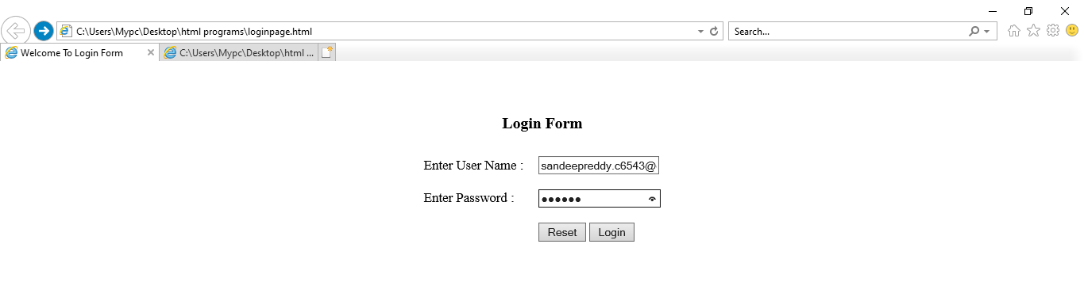

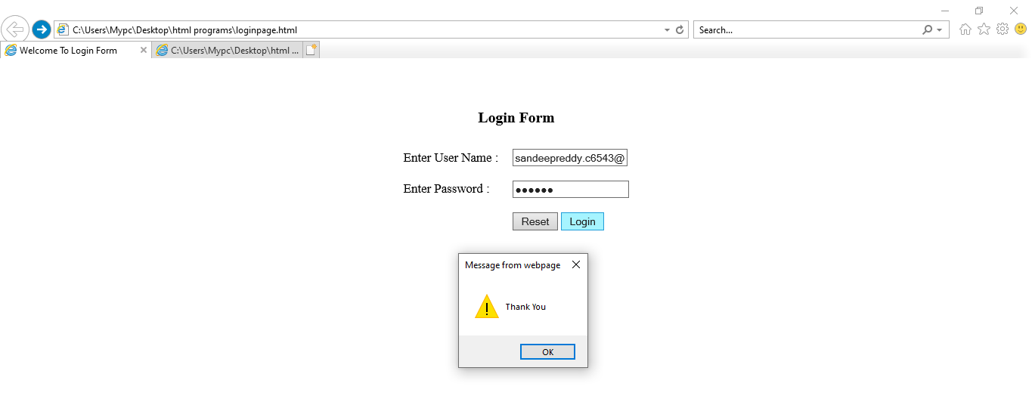

Home.html

<!DOCTYPE html>

<html>

<head>

<title></title>

</head>

<body>

<br><br>

<center>Welcome User</center>

</body>

</html>

